# Introduction:

This is Software Requirements Specification Document for --------. This Application would be used to compare optimization algorithms that could help the researchers to get the results of their applied algorithms.

## Purpose:

This SRS describe the functional and non-functional requirement for our application and it may include a set of use cases that describe user interactions that the software must provide. This document is intended to be used by developers only.

## Document Conventions:

|  |  |
| --- | --- |
| Functional Requirements | Hierarchical numbering convention is used while writing functional requirements. Functional Requirements with ‘*’ are further elaborated by use cases. |

# Overall Description:

## Project Scope:

This application is intended to be used just for presenting research results. Therefore, is scope is limited.

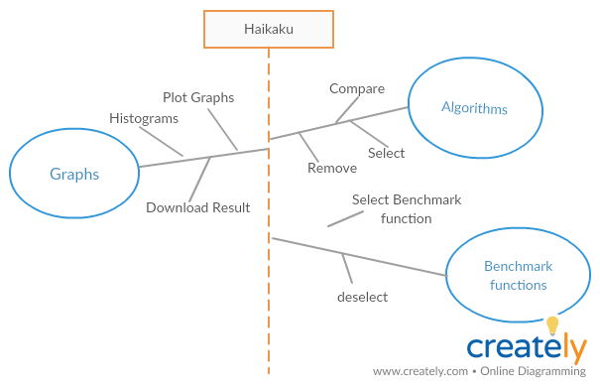

## User classes and characteristics:

Intended users are:

1. Researchers
2. Teachers
3. Students

# Operating environment:

# System Features:

## Algorithm:

## Description:

This feature shall enable user to select desired algorithm and run it on a specific Evaluation Function and then user can visualize results in the form of graphs

## Functional Requirements:

|  |  |
| --- | --- |
| Number | **Functional Requirements** |
| 4..1.3.1 | The system shall be able to provide the facility to select the Algorithm which needs to be run in a combo box. User inputs the tunable parameters in the pop-up shown. |
| 4.1.3.2 | The system shall be able to provide the facility to dis-select the Algorithm |
| 4.1.3.2 | The system shall be able to provide the facility to compare the selected algorithms. |

## 4.2.1. Benchmark Functions:

## 4.2.2. Description:

This feature shall enable the user to select desired benchmark functions and the algorithms run and gives results for each benchmark function. The results will be displayed separately in form of graphs for each benchmark functions.

|  |  |
| --- | --- |
| Number | **Functional Requirements** |
| 4.2.3.1 | The system shall be able to select the benchmark function which needs to be run in a combo box. |
| 4.2.3.2 | The system shall be able to provide the facility to dis-select the benchmark function. |

## 4.3.1. Graphs:

## 4.3.2. Description:

This feature shall enable the user to the compare the results of selected algorithm by plotting the results of each benchmarks functions separately in a graph. User can be change the graph type in the option given graphs

|  |  |
| --- | --- |
| Number | **Functional Requirements** |
| 4.3.3.1 | The system shall be able to provide the facility to plot graph for a certain benchmark function on selected algorithms. |
| 4.3.3.2 | The system shall be able to provide the facility to download the graph plot result in form of pdf. |